**HR-ONE**

21.05.2021

─

Mentor : Ankit Gupta

Hitesh Jivanani

Software Engineer

Bigstep Technology

2nd Floor, SCO-63, Old Judicial Complex Civil Lines Rd, Sector 15

Gurugram, Haryana 122001

# Overview

* An HRM system, or HRM software, is designed to automate human resource business processes, transactions, payroll, and compliance.
* To make a fully functional Attendance Management System for Company where attendance marking and approval can be done.

# Functionality

* Login
* Mark Attendance
* Add user (Only for Admin or selected user)
* Attendance correction
* Apply for leave
* Attendance/ Leave approval (by user’s mentor)
* Find user (Employee directory)
* Edit user’s details (by selected user)
* Logout

# Login

# Home page

#### Choose option & Mark Attendance:

##### Check in

##### Check out

* You must have to select an option.
* You can not check out without check in first.
* You can check in and check out once only in a day.
* If your working hours are less than 9, then It will show a warning message for the same.
* If hours < 9 then it will mark attendance as half day. You can also apply attendance correction.

#### Add user

* This button is only for the admin or specific users.
* You can add an employee or user by clicking on this.
* After clicking this button :-> just fill all the fields and Register. It will store all the data in the database.
* 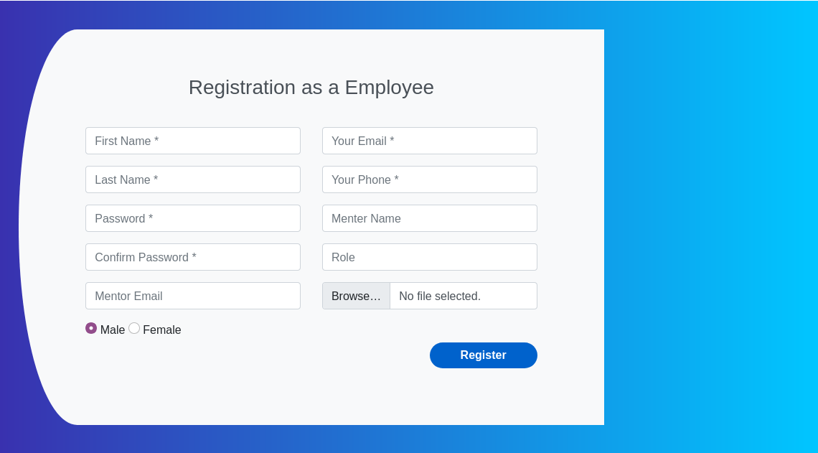

#### Find people :

* From this you can search employee view their details.
* 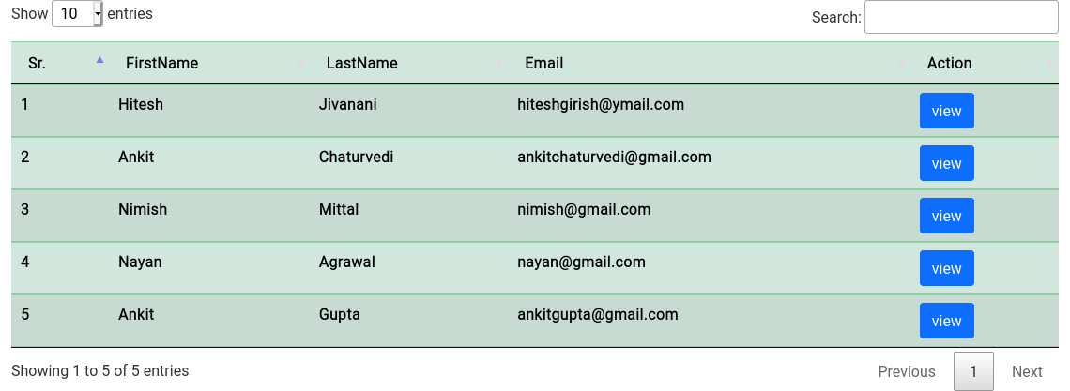

###### View :

* + - By clicking this button(View button) it will show the full details of the employee.

FunctionalityFunctionali

Functionality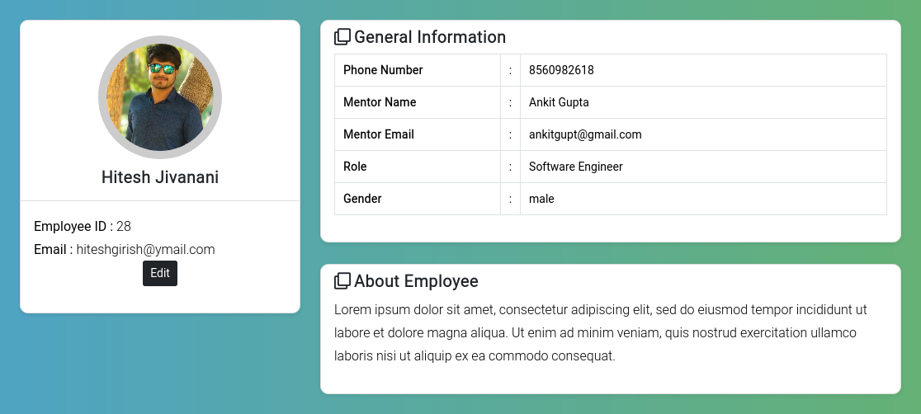

###### Edit :

* This is only for the admin or specific user.
* By this admin can edit the details of any employee.

# Navbar

### 

### Navbar -> Approval -> Leave :

* In this section you can check your approved or rejected leaves.
* Approve and reject done by only employee’s mentor.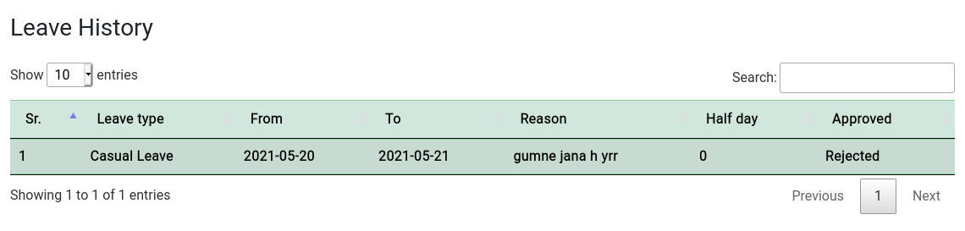
  + Half day = 0 -> full day
  + Half day = 1 -> half day

### Navbar -> Approval -> Attendance :

* In this section you can check your approved or rejected attendance.
* 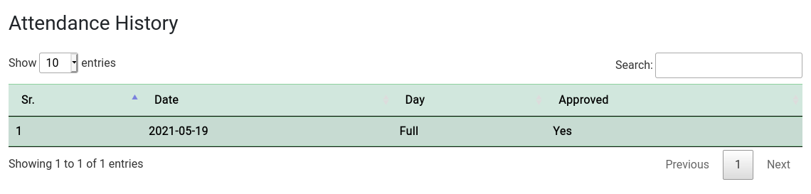
* In this you can see your attendance history. It will also show approval or not.

### Navbar -> Request -> Leave :

* In this section you can apply for the leave.
* These leave requests will show on your menter page.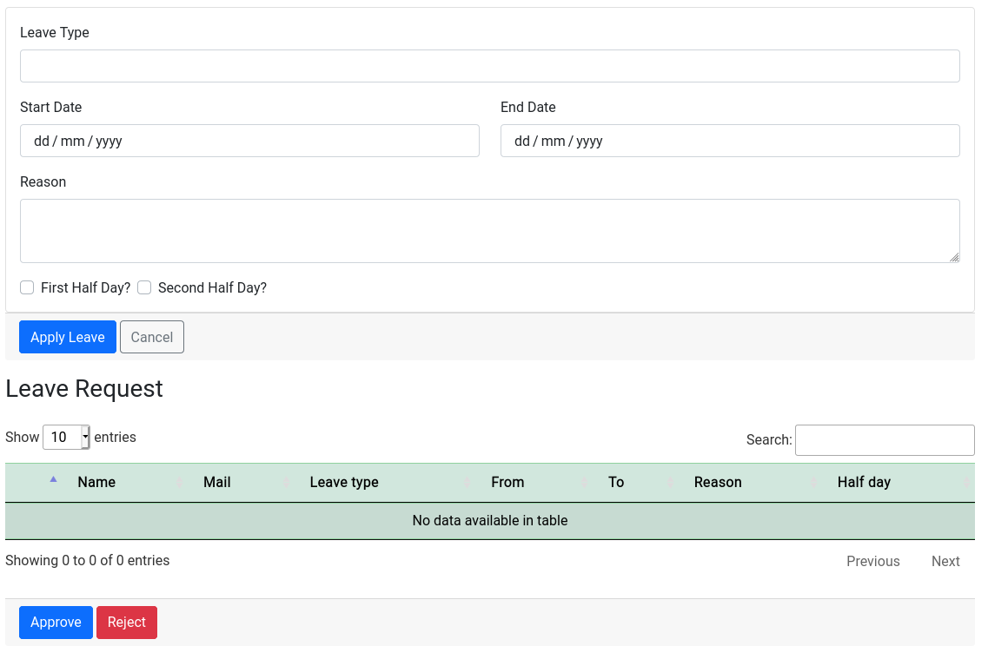
* Mentors can accept or reject these leave requests.
* And after accepting or rejecting the request it shows up in the approval->leave section with status : Accept / Reject / Pending.

### Navbar -> Request -> Attendance :

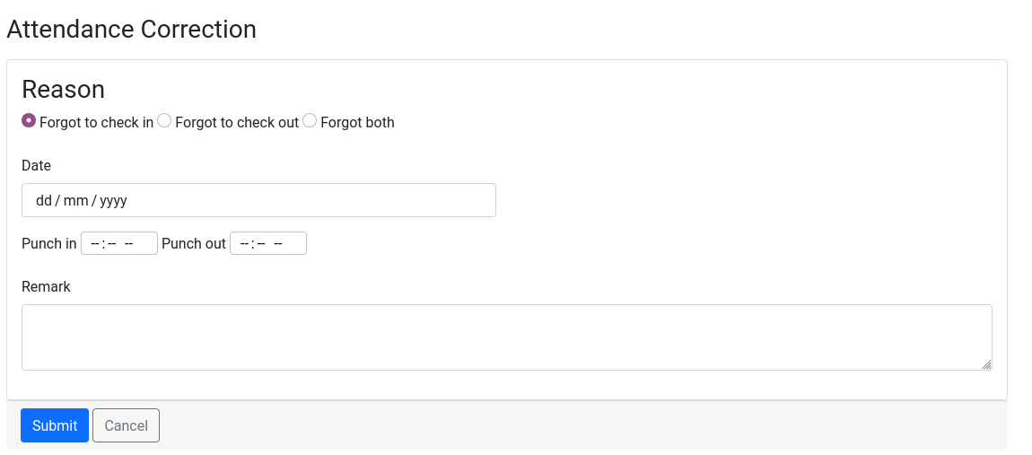

* This for Attendance correction if you forgot the check in and check out or both by mistake.
* These requests will show up in your mentor’s account.
* If you're a mentor, your request will appear in these tables; otherwise, they'll be blank. You have the choice to accept or deny it.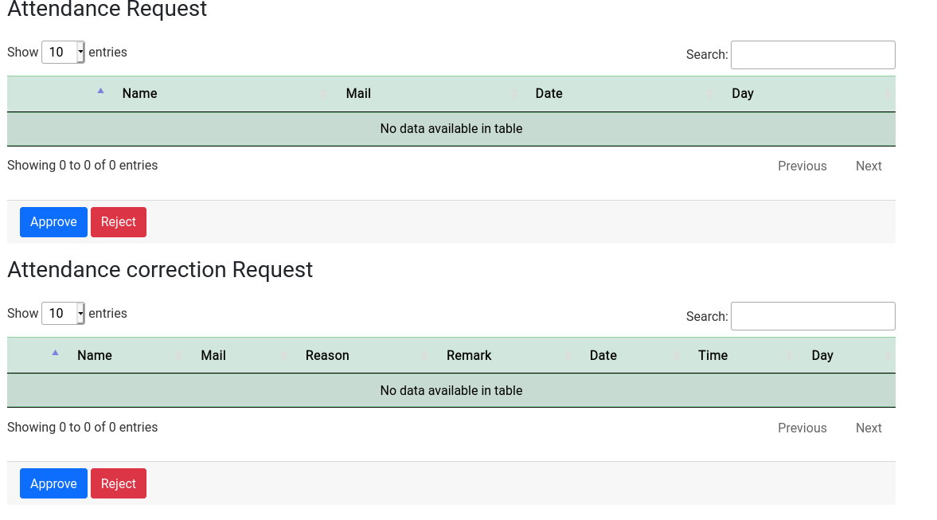

# Logout :

* You can logout by clicking on the logout button.
* Session will be destroyed. After you have to login again.

# Database schema and tables :

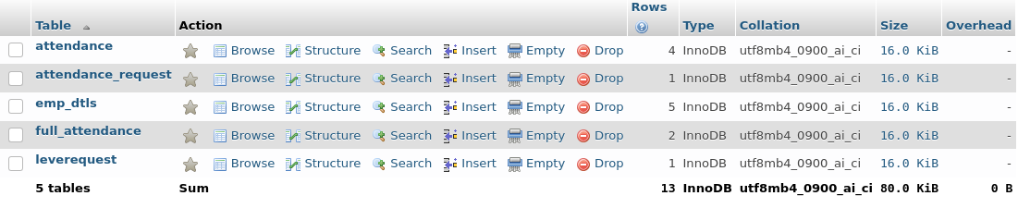

* Emp_dtls :
  + For employee details
* Attendance_request :
  + For all attendance request
* Attendance :
  + For check in and check out request
* Full_attendance :
  + For record of every employee’s attendance.
* Leaverequest
  + For leave requests.